**SHAH**

**The idea for the project is to play online chess against friends , rivals and people who want to have fun , also to hone your skills playing against a computer and to get better every day.**

1. **How to run the project** 
   1. **Prequisites : Docker(Docker compose)**
   2. **How to run : Download the project , run docker compose up –build ,**

**Start playing chess**

**2 Used Technologies :**

**-Database : PostgreSql , gorm**

**- Frontend : templ + htmx + tailwind + bootstrap**

**Other :**

**- Reddis, Gorilla Mux, Docker , Kubernetes , TeraForm , GitHub Actions,**

**Web Socket, Google UUID**

**3 Architecture of the Project**

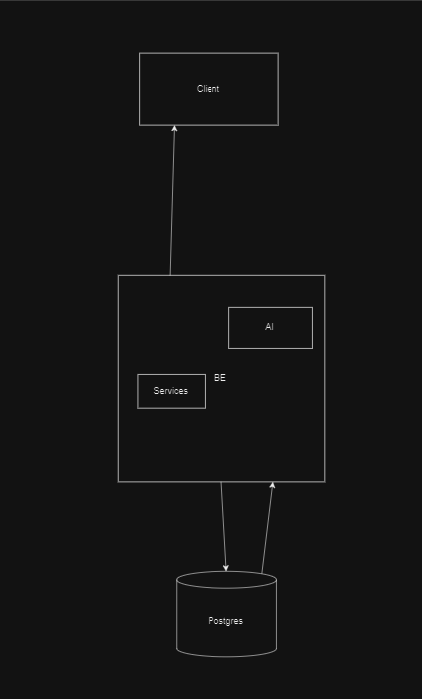

**For the Database Postgres was picked due to our previous experience with it,**

**For the frontend we kind of tried new thing and went with what looked best.**

**The Client Server Communication is done in two versions :**

**For the simple pages like news , users profile etc it is used simple REST API,**

**For the Live game the Live chat and so on, web sockets are used .**

**Resources :**

[Introduction | templ docs](https://templ.guide/)